PO AND MIGO FOR PURCHASE OF MATERIAL FROM VENDOR
USE T CODE: ME21N
SELECT NEED BASE ODRER
ENTER VENDOR CODE
ENTER PURCH ORG-2000, PURCH GROUP-040 AND COMPANY CODE-1024
ENTER MATERIAL NO ,ENTER PO QTY, ORDER UNIT-NOS,NET PRICE-COST OF INDIVIDUAL ITEM WITHOUT TAX,PLANT-2419 FOR NASIK, STORE LOCATION AT APPROPRIATE TAB.
ENTER TAX CODE-I1
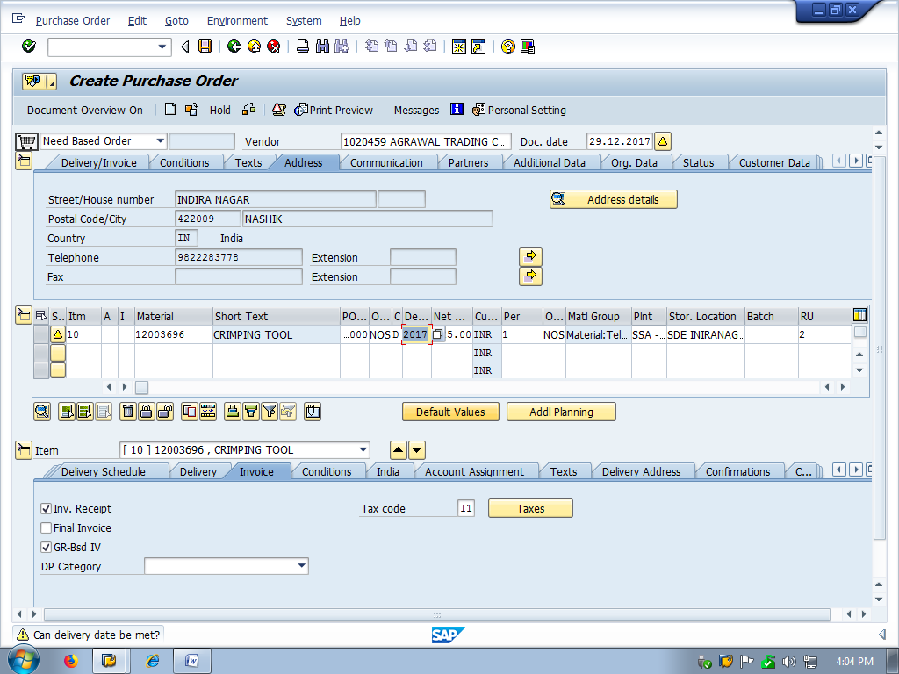
CHECK TOTAL BILL AMOUNT INCLUDING TAX UNDER CONDITION TAB
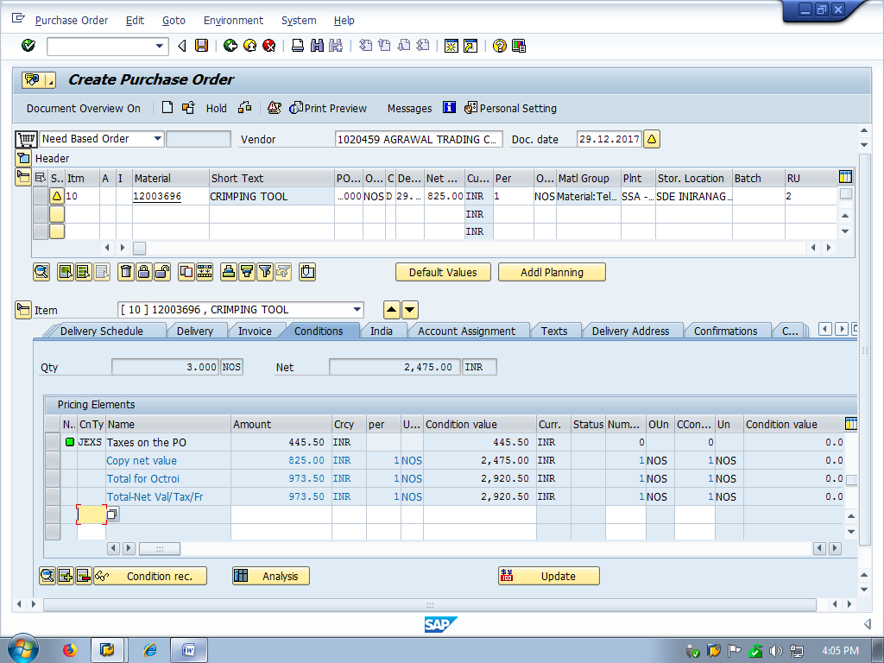
SAVE PO
NOTE DOWN PO NO AT BOTTOM LEFT.

To take print out of migo
Steps
Use T code migo –Select display, Material document ,then enter doc number[migo number],Execute
Tick on box to the left of collective slip, you will see.
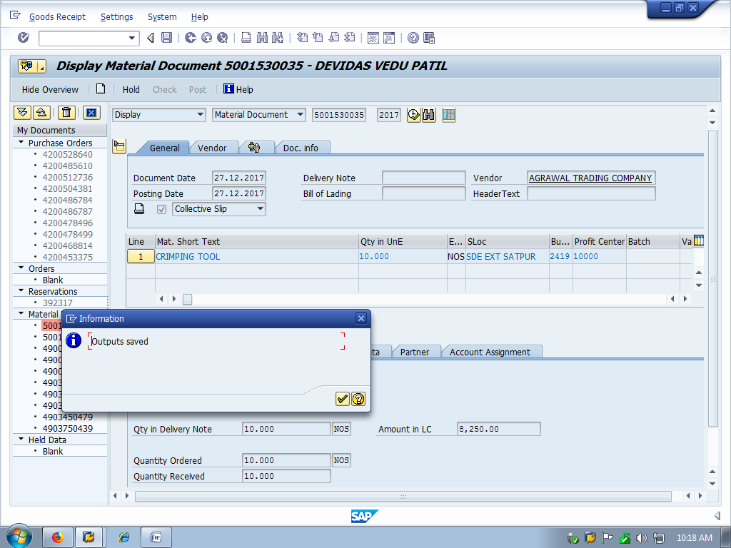

Now use T code Mb90
Enter Output type:ZGR,Transmission medium 1,Sort order -01 ,processing mode:1 [for first time print, 2 for consequent time print], Execute

You will see
Tick in check box of material document and click on execute

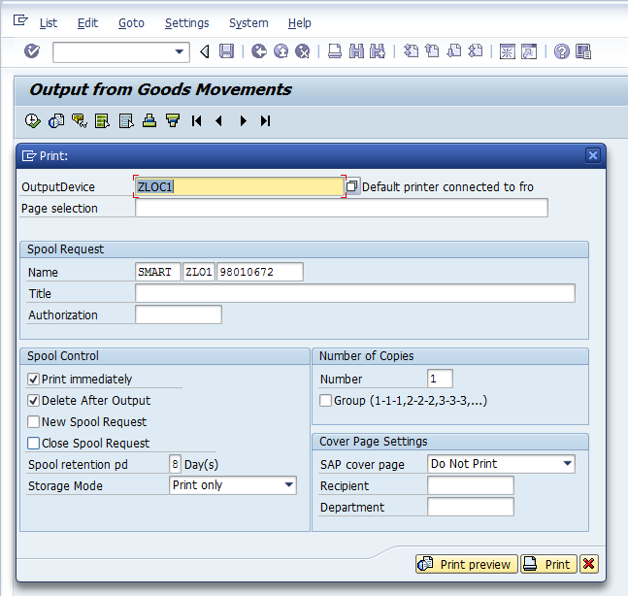
See print preview before taking print if you wish.
