HOW TO DELETE PO AND SES 29.12.2017
PRECONDITION: PO AND SES HAS TO BE FINAL RELEASED [APPROVED]
PROCEDURE : FIRST DELETE SES
USE T CODE : ML81N  SELECT OTHER PURCHASE ORDER  ENTER SES NUMBER  EXECUTE/ENTER  CLICK ON CHANGE  CLICK ON RELESE BUTTON  SELECT R1  ENTER POSTING DATE AND DOCUMENT DATE  SAVE | AGAIN CLICK ON CHANGE BUTTON  SELECT ENETERRED SERVICES [LINES 10,20 ETC  DELETE BY CLICKING ON - [MINUS] SIGN  NOW SES IS DELETED
-----------------------------------------------------------------------------------------------------------------------------------------
THEN DELETE PO [ PO STATUS HAS TO BE APPROVED]
USE T CODE ZMMP_INI_AMEND
SELECT PURCHASE ORDER FROM DROP DOWN MENU IN DOC TYPE
EXECUTE
PO COMES IN INBOX [CHECK]
NOW USE T CODE ME22N
SELECT LINE 10,20 ETC, DELETE THESE LINES BY CLICKING ON DELETE SYMBOL, THEN SAVE
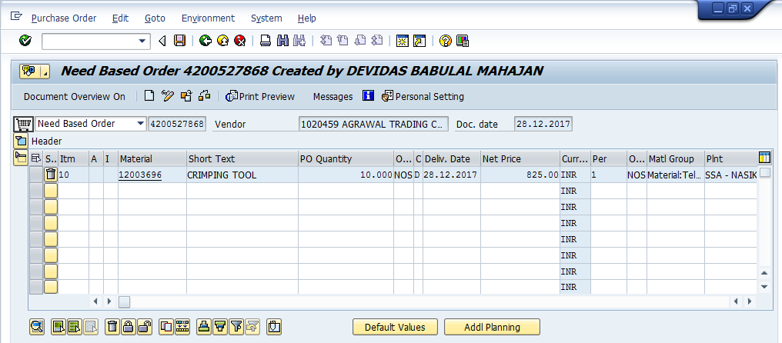
SAVE

